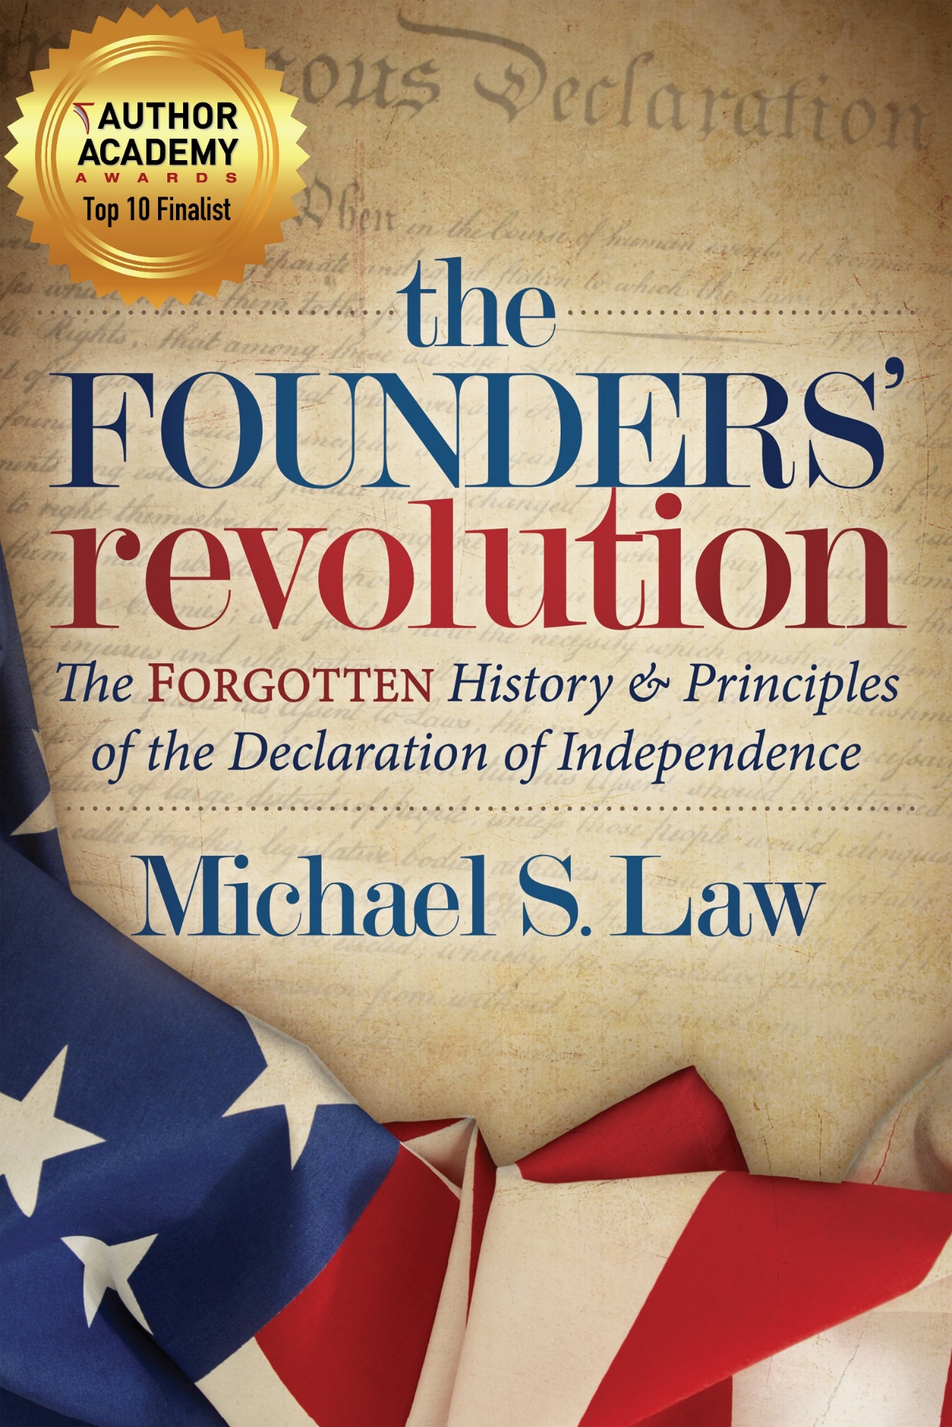
the FOUNDERS’ revolution
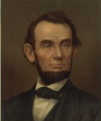
“Let me entreat you come back…to the truths that are in the Declaration of Independence,” pleaded Abraham Lincoln.

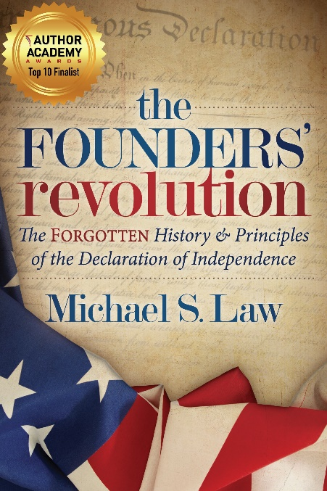
Has America forgotten and strayed from the principles of the Founders?
Rediscover the forgotten history of how the Declaration of Independence came into being and the principles that form its foundation. Learn why the Founding Fathers drafted the Declaration and the historical circumstances that led up to it.
From the words of the Founding Fathers, as well as other original source documents, you will gain insight into every charge and claim the Founders made in the Declaration. You will also uncover what the Founders intended America to become with their lofty, yet practical, ideals of the proper role of government.
Find out just how far America's modern-day federal government has strayed from the Founders' principles and what you can do to help return America to those bedrock truths.

Author: Michael S. Law
Title: The Founders’ Revolution: The Forgotten History and Principles of the Declaration of Independence
Paperback: 234 pages
Published: April 3, 2018
ISBN-10: 1683505859
ISBN-13: 978-1683505853
About the Author/Speaker
Michael S. Law has focused much of his life’s research on the Founding Era and the Founders of the US. Michael has a bachelor’s in political science from Boise State University and a master’s degree in political science from American Public University emphasizing US history and government. Michael continues to personally study from the writings of the Founders and their history, remaining focused on the Founding principles. Michael applies his political expertise locally, including involvement in local government through serving on his local school board until 2016. Michael has been heard on numerous Fox Radio Network stations as a political analyst. Michael has been married for twenty-five years to his wife, Kaori, and has three children.

Connecting with Michael

pronralaw@gmail.com

www.michaellawauthor.com

@michaelslawauthor

@MichaelLawIdaho

Endorsements/ Reviews
"Michael Law’s The Founders’ Revolution is a revealing and much-needed retelling of the writing of the Declaration of Independence and the events that led up to it. But this is more than a book of history. Law brings out connections between the reasons for the Founders’ revolt and what’s going on in America today. He shows how our federal government is committing similar wrongs against us today as England’s king and Parliament did to Americans centuries ago. The Founders’ Revolution is a rallying cry for Americans to pay closer attention to their own government’s actions and to hold officials accountable for their decisions against us, the electorate. Pay heed to what Law has to say. We are losing our liberties―and we do not have to!" - William D. Watkins, award-winning author; author of The New Absolutes; former director of publications for The American Center of Law and Justice

“I have a significant library of historical volumes, and I’m most gratified to add this one to my shelves. I know Law’s book is one I will refer to over and over again in the future as I research material for projects at hand.” – J.L. Callison, Author of Stranded at Romson’s Lodge

"It is a fascinating read in truth. Every elected official should read this book." — Jim Chmelik, Former Idaho County Commissioner

Well-documented history that reminds us of how the United States came about and what our Founding Fathers had in mind when drafting our country’s Declaration of Independence. Law helps readers get more insight in the meaning behind the words they chose and the circumstances that occurred to ignite the revolution. He clearly demonstrates the Founding Fathers’ vision for the role of government and gives examples of how our current federal government is mimicking the way Britain’s King George III violated the crown’s own documents at the time. I am optimistic that readers will be inspired to engage in politics and hold our government accountable. – Leslie Sorrell, Author of From Clients to Crooks: An Insider Reveals the Real Washington D.C.

Michael’s book should be in every high school's curriculum…Sure to garner dialogue between readers. – Chad, Idaho

I love American history and think this book is a MUST read for anyone interested in revisiting the importance and brilliance of our founding fathers. – Martha B. Boone, Author of The Big Free

Michael Law's book is a well-written deep dive into our nation's history that made me wish I could go back in time to a day where Americans truly appreciated the fight for life, liberty and the pursuit of happiness...and then made me realize that we all must continue to take a stand for what our forefathers fought so hard to establish. – Michele, Maryland

Given the current political environment, The Founders Revolution is a timely read. – Lori, North Carolina

Michael Law dives deep into history in ways that you've never seen before. – Karen, Illinois

As a Canadian I appreciated this book by Author Law. It took me on a historical journey into the minds of the Founding Fathers of America. Having not read the Declaration of Independence or US Constitution before I found this book a great reference and learning tool to better understand my Southern neighbour USA. I recommend this book! – Tom Dutta, CEO & Founder of KRE AT

The Founders’ Revolution goes behind the scenes of one of the greatest documents ever written. It skillfully tells the history, thoughts and emotions of America’s founding fathers. I applaud the depth of research that Michael Law undertook in identifying the historical documents and for navigating the reader through the difficult events that led to the declaration. I highly recommend this book to anyone wanting a better understanding of our government, the intent of our founding fathers and the incredible providence of God in establishing the United States of America! – Doug, Ohio

Chapter overview of the Founders’ revolution

Chapter 1: The Course of Human Events
The political connections to England are described including ties with the Magna Carta and the English Bill of Rights of 1689. Introduction to why a separation from England was necessary. Introduces and explains the ideas of natural law and of nature’s God. Provides historical background of the physical separation from England that forged the political separation, discussing the individual charters that provided political authority to the colonies
Chapter 2: Unalienable Rights and the Proper Role of Government
Introduces the ideas of what rights are and how rights are derived. Describes truths that are self-evident, such as the right to life, liberty and property. Explains the Founders’ views on “all men are created equal.” Provides the ideas of the purpose of government and when the people may change their form of government.
Chapter 3: The Charges: Abuses of Executive Power
Describes the first twelve charges of abuse by the King George concerning the powers of the executive. These abuses of executive power include dissolving legislatures, obstruction of justice, erecting numerous government offices to harass citizens, and keeping armies among the citizens. Also, gives examples of modern government abuses of executive power similar to the abuses of King George.
Chapter 4: The Charges: Abuses of Legislative Power
The next ten charges are abuses of legislative powers by King George. These charges include taxation without representation, no trial by jury, altering colonial governments, and declaring themselves (Parliament) with power to legislate in all cases whatsover. More examples of modern abuses demonstrate current government acts of abuse.
Chapter 5: The Charges: Abuses of War Power
Five more charges of abuse of war powers listed and explained. A couple of abuses plundering and destruction of towns, using mercenaries in war, constraining POW’s to fight for England. Examples of modern-day abuses provided. A “deleted charge” in the original draft of the Declaration of Independence is also included.
Chapter 6: Reconciliation Attempts
Evidence demonstrating the failed colonial attempts to reconcile with England, both with government and with their fellow-citizens, which were answered with repeated injuries.
Chapter 7: Separation and the Appeal to Heaven
Argues the case for the separation from England by appealing to a higher authority over the king. Provides evidence of the Founders’ pledge of support and a few historical examples of the Founders’ dedication to the fulfillment of the support and the price many paid for independence.

Sample Interview Questions
About the Author: (about 3 minutes each)
- Why did you decide to write the Founders’ Revolution?
- What did you do to entice a publisher to print the Founders’ Revolution?
- Have you been involved in the political sphere? If so, have you tried to apply the principles that you discuss in the Founders’ Revolution?
- How can people contact you and where can they go to purchase the Founders’ Revolution?
About the book: (about 5 minutes each)
- The subtitle of the Founders’ Revolution is “the Forgotten History and Principles of the Declaration of Independence.” What has been forgotten?
- Why do you think it is important for people to learn the history of the Declaration? What about the principles?
- When most people are asked why the United States declared independence, they say “taxation without representation.” Is that the only reason? What are other reasons?
- Is government today repeating what the British government did over 200 years ago? If so, how?
- What examples can you provide that demonstrate that government is violating the principles of the Declaration?

MICHAEL S. LAW
About Michael:
- BA, MA- Political Science, US History, Government, emphasis
- Author of “The Founders’ Revolution: The Forgotten History and Principles of the Declaration of Independence”
- Speaker
- Fox Radio Network Political Analyst
Speaker – Author – Fox News Radio Contributor
Helping America Rediscover and Return to her Foundational Principles
“Let me entreat you to come back…to the truths that are in the Declaration of Independence.” – Abraham Lincoln, 16th President of the United States.
Topics:
Rediscover Forgotten History of the Declaration of Independence and how it still applies.
What history has been forgotten? How can the Declaration provide direction to citizens and politicians today? Michael describes all 27 violations of rights by the king and how government today is similarly violating. Why representatives and citizens must understand the history of the Declaration.
Book Michael Law
208-761-7290 www.michaellawauthor.com pronralaw@gmail.com

America’s Foundational Principles of Good Government
Explore the ideas of Natural Rights and why having a foundation of government built on natural rights is vital. Understand why acknowledging right endowed by a Creator is important. Michael explains what the proper role of government is, how the Founders of America got it right and why America must return to those foundational truths.

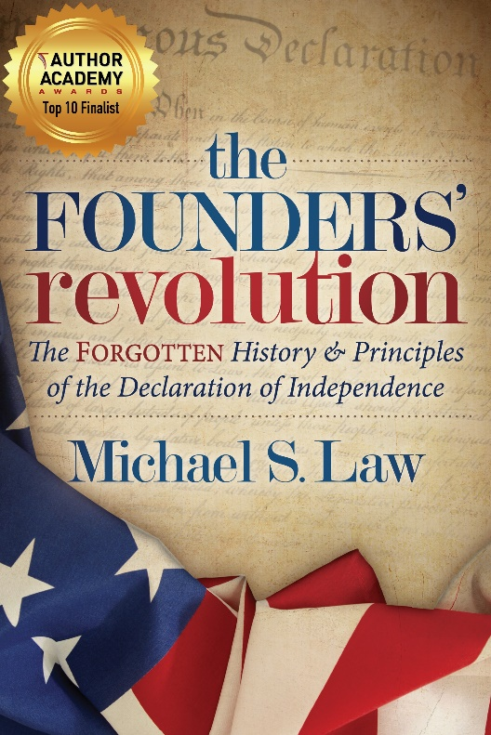
About Michael’s book…
the FOUNDERS’ revolution
Has America forgotten and strayed from the principles of the Founders?
Rediscover the forgotten history of how the Declaration of Independence came into being and the principles that form its foundation. Learn why the Founding Fathers drafted the Declaration and the historical circumstances that led up to it.
From the words of the Founding Fathers, as well as other original source documents, you will gain insight into every charge and claim the Founders made in the Declaration. You will also uncover what the Founders intended America to become with their lofty, yet practical, ideals of the proper role of government.
Find out just how far America's modern-day federal government has strayed from the Founders' principles and what you can do to help return America to those bedrock truths.

What others are saying about Michael’s book:
This is fantastic… if you love history and you love this country! Speaking of the Constitution, if we ever had the need to understand what our Founders believed, what they intended… I’ve got a great book for you to read. It teaches you and your children some incredible principles about the Constitution. Everything in the book is from the original source documents. Original sources are what we need today because those have not been tainted by progressivism. I absolutely love it! — Pat Gray, Radio/Podcast Talk show host
Learning about and understanding the Founding is vital to the survival of this nation; for if we lose the foundation, the whole house will crumble- Michael S. Law

Michael Law’s The Founders’ Revolution is a revealing and much-needed retelling of the writing of the Declaration of Independence and the events that led up to it. But this is more than a book of history. Law brings out connections between the reasons for the Founders’ revolt and what’s going on in America today. He shows how our federal government is committing similar wrongs against us today as England’s king and Parliament did to Americans centuries ago. The Founders’ Revolution is a rallying cry for Americans to pay closer attention to their own government’s actions and to hold officials accountable for their decisions against us, the electorate. Pay heed to what Law has to say. We are losing our liberties―and we do not have to! — William D. Watkins, award-winning author; author of The New Absolutes; former director of publications for The American Center of Law and Justice
Book Michael Law
208-761-7290 www.michaellawauthor.com pronralaw@gmail.com

